1.Counting element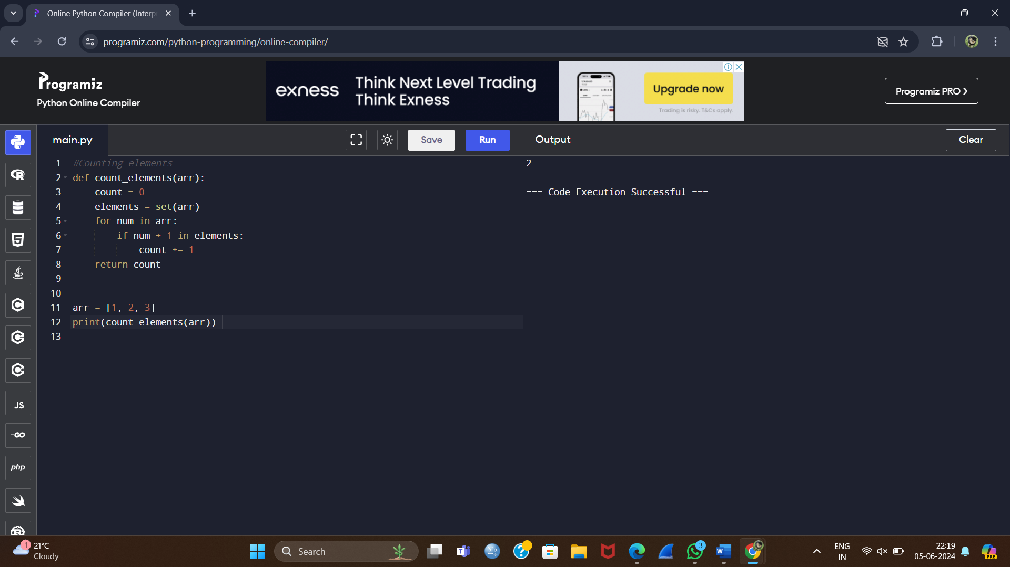

2.Perform String Shift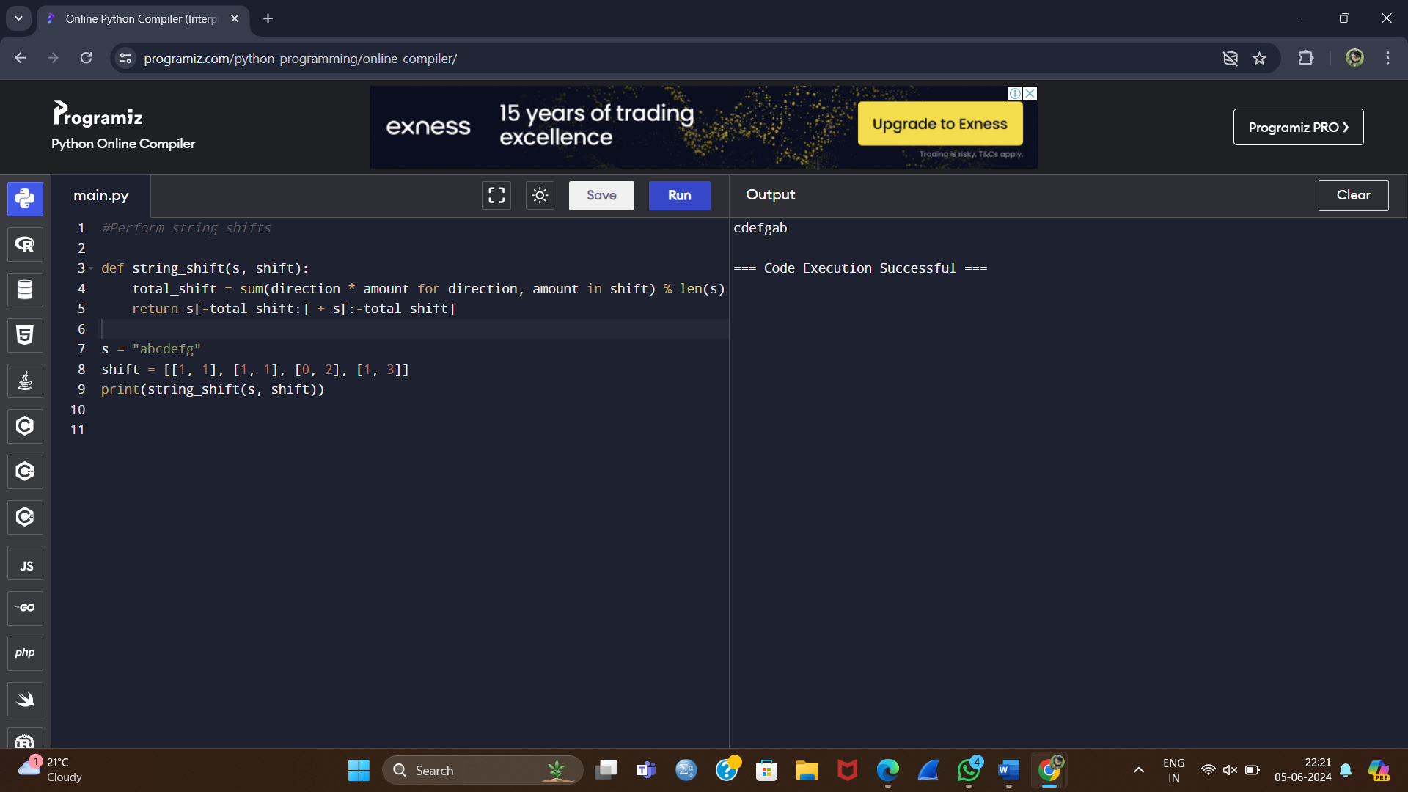

3. Leftmost Column With at Least a One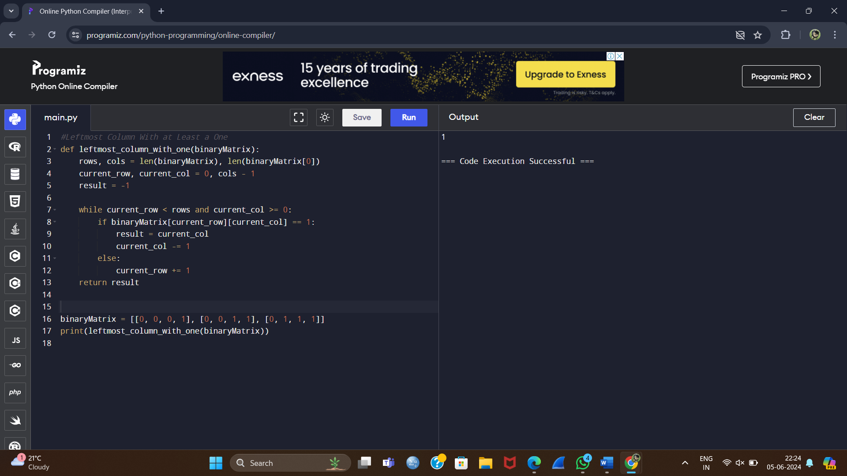

4.First Unique Number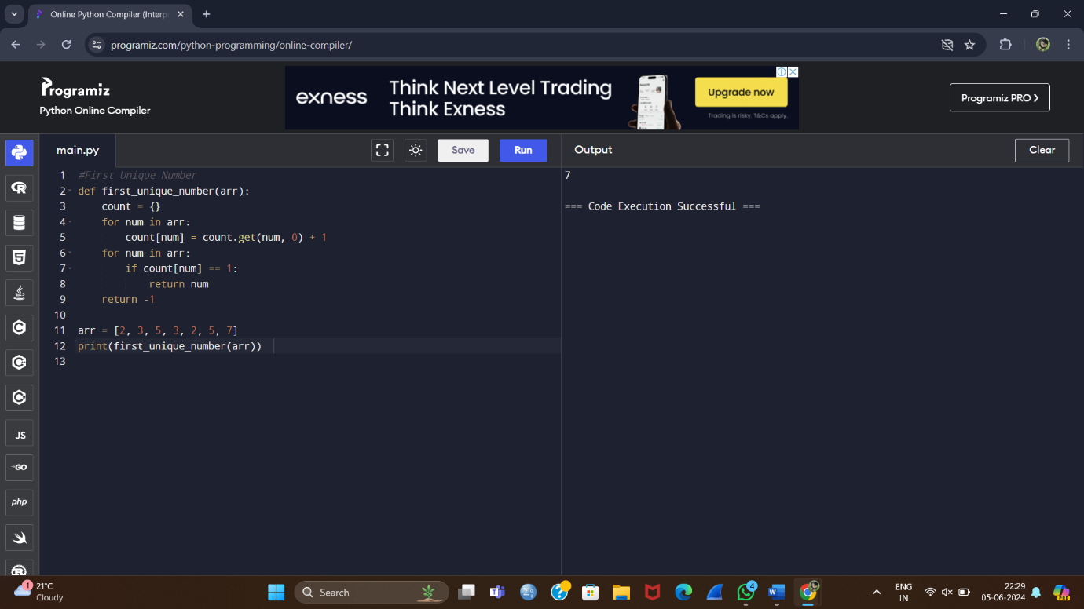

5. Check If a String Is a Valid Sequence from Root to Leaves Path in a Binary Tree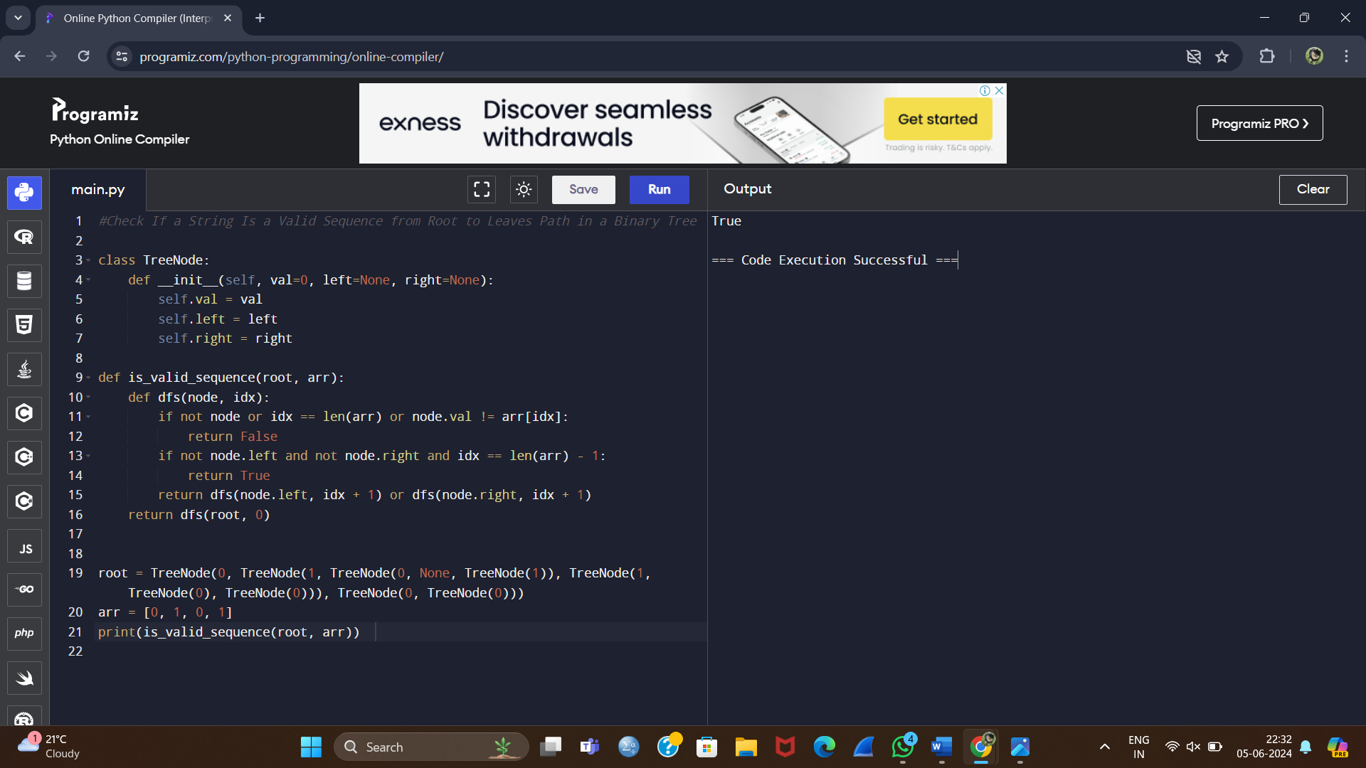

6. Kids With the Greatest Number of Candies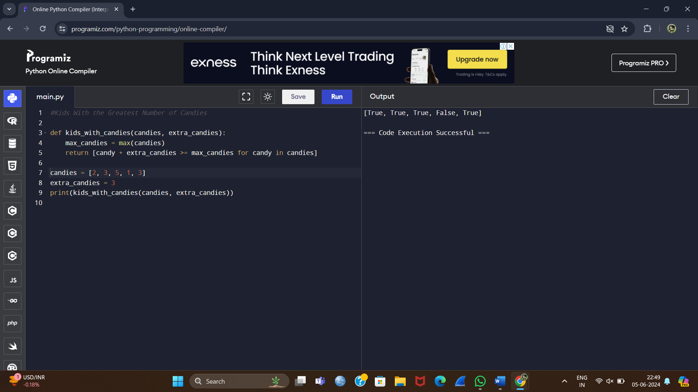

7. Max Difference You Can Get from Changing an Integer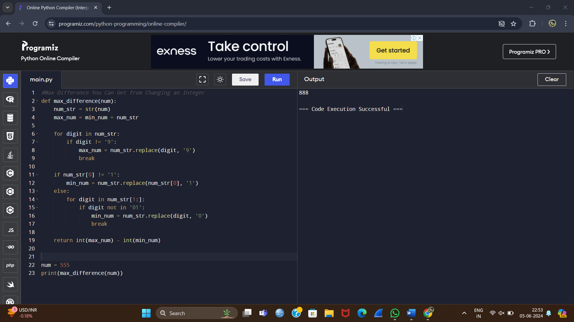

8. Check If a String Can Break Another String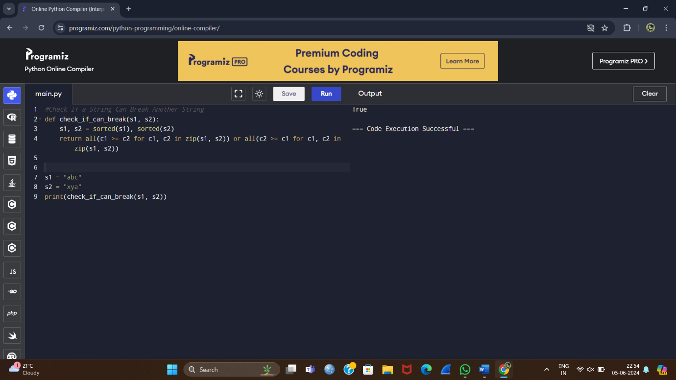

9. Number of Ways to Wear Different Hats To Each Other

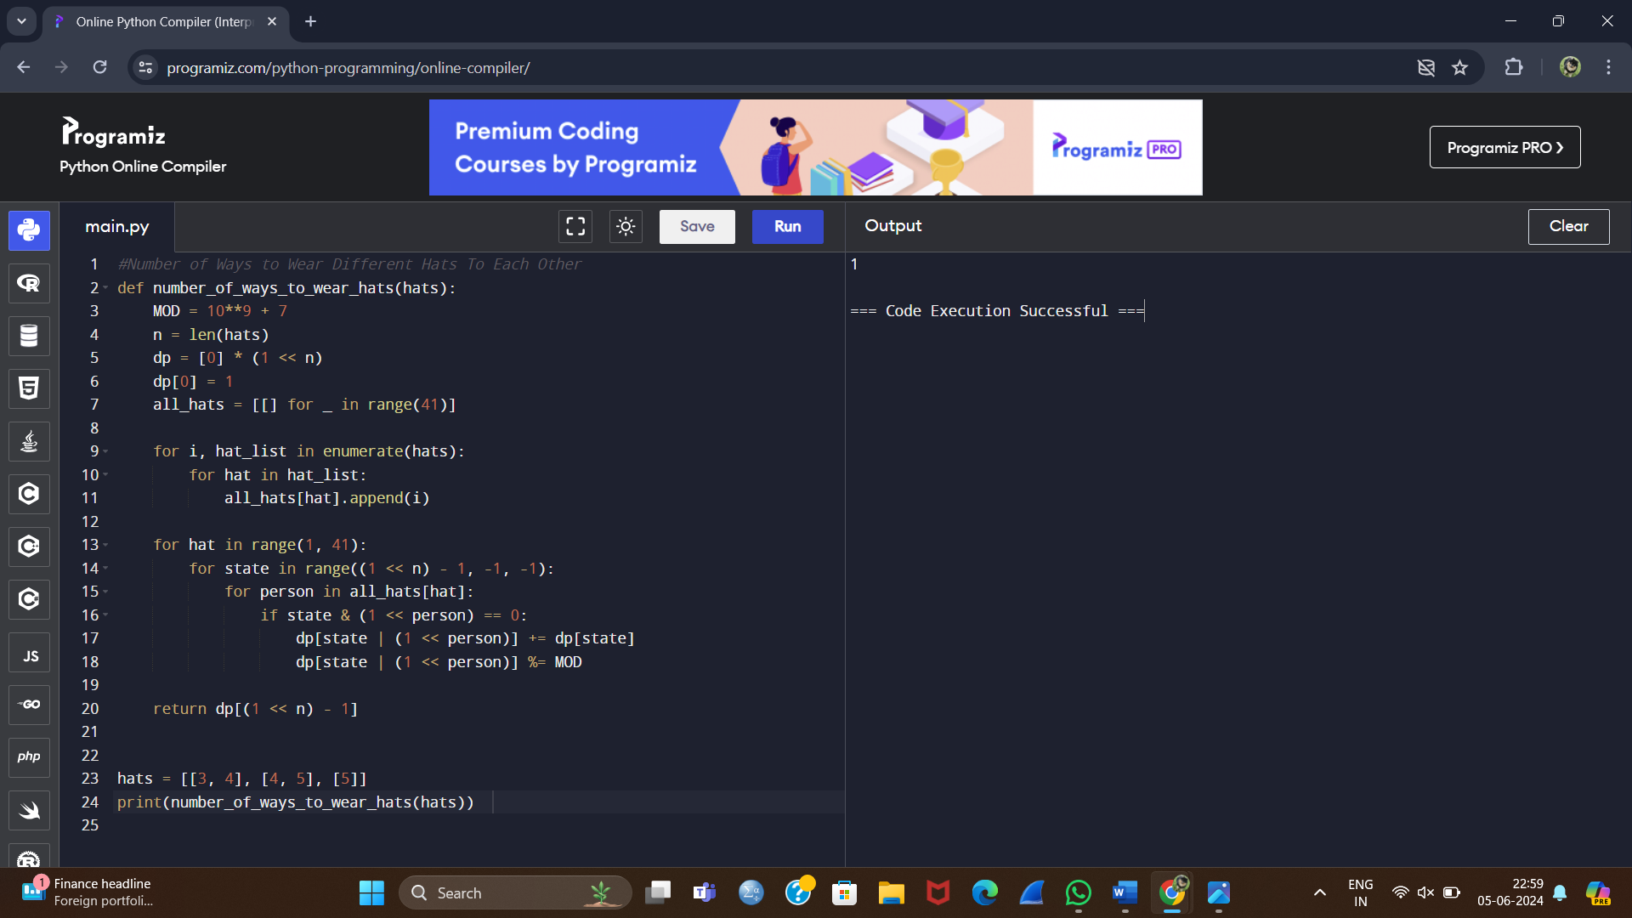

**10.Next Permutation**